CHEF IN SHORTS:

* Suppose we want to create 10 users across 10 VM's so Direct approach would be logging to each system and creating users
* Suppose If I have 100 systems then doing same task will become complex, this is where we go for scripting,
* Scripting has its own challenges where we need to consider all cases and each OS conditions may vary, and Scripting knowledge is a must
* In order to overcome this we go for automation tool like CHEF, ANSIBLE, PUPPET
* Writing each and every step and considering all conditions to achieve a particular task is nothing Imperative Programming Pattern
* Specifying just the outcome is with just few lines of code is nothing but declarative programming pattern
* There are two types of Configuration Push based and pull based, Push based is like ordering a food and server will deliver u the food where server will push the configurations to node, Pull mechanism is more like taking food in buffet, here node will initiate the configurations
* An Idempotent task is one which yields same result when called repeated multiple times, like if user is already present then it will not create that specific user
* Convergence means is brining all together
* Chef is a RUBY based IT automation tool used to configure, manage, deploy and orchestrate various application across infrastructure
* 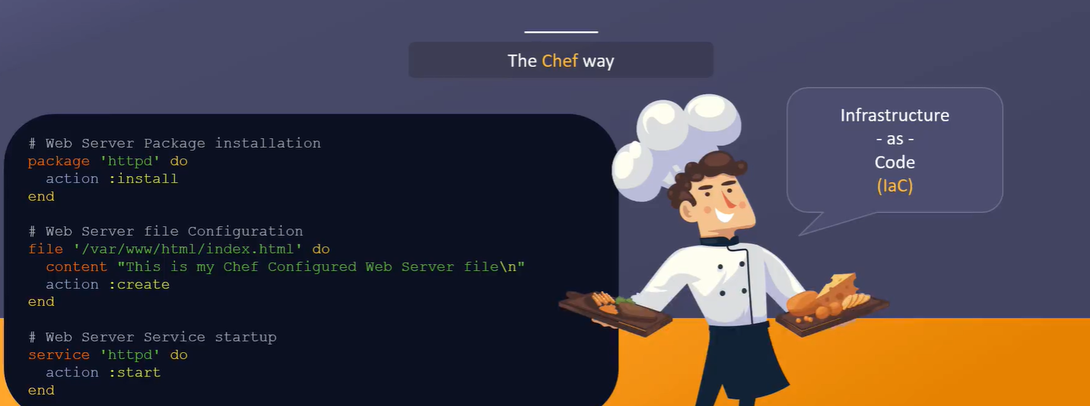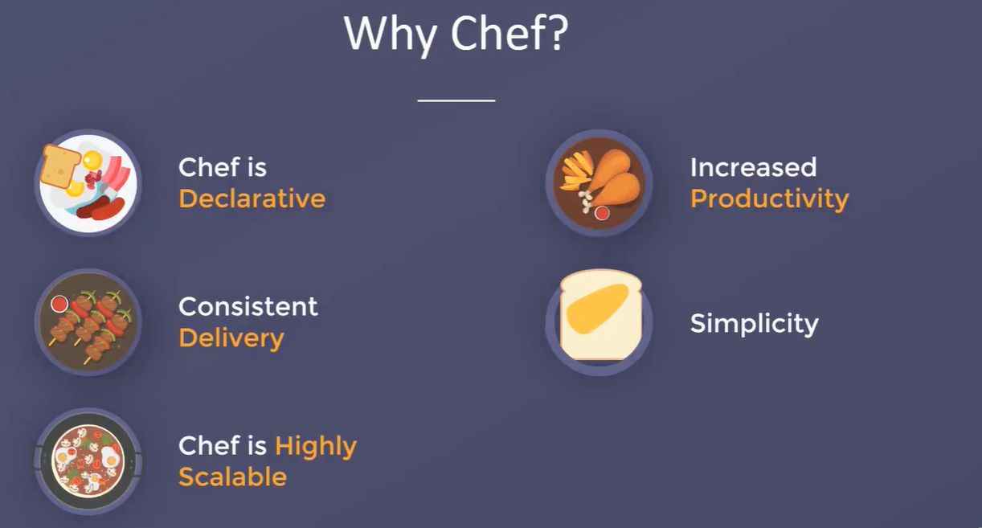
* There are two kinds of models in CHEF chef Server – Client and CHEF Zero , The server – client is use of production version where as chef zero is used for developing and testing cookbooks locally
* 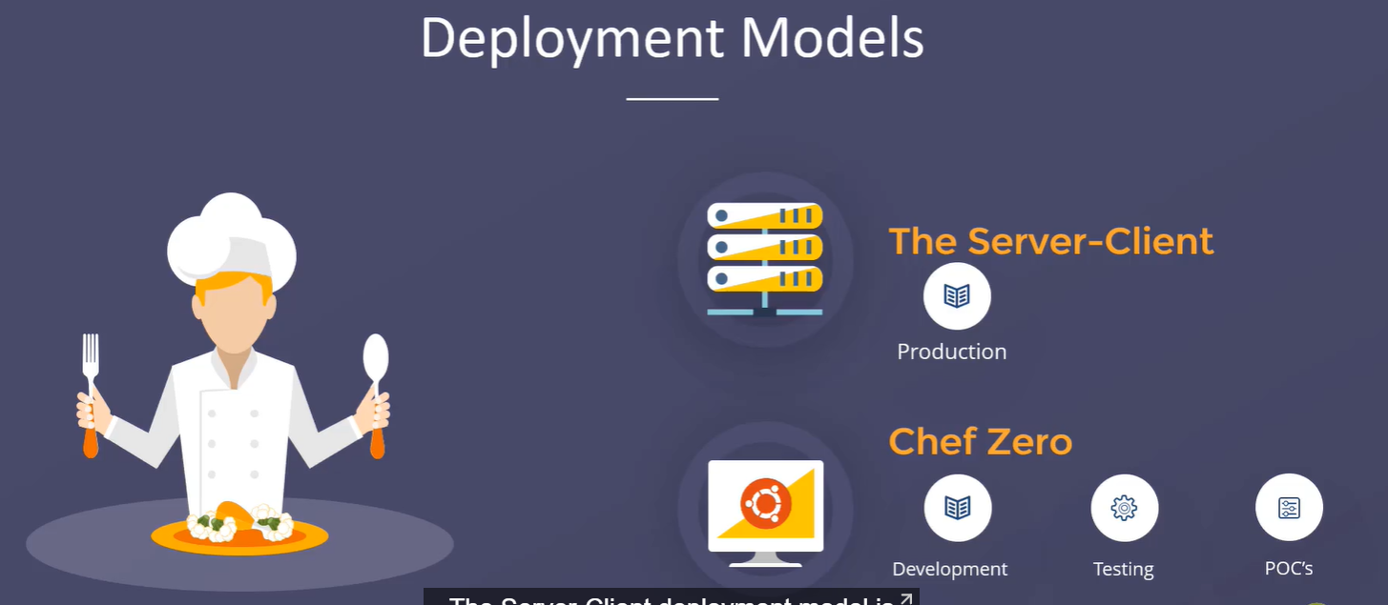
* 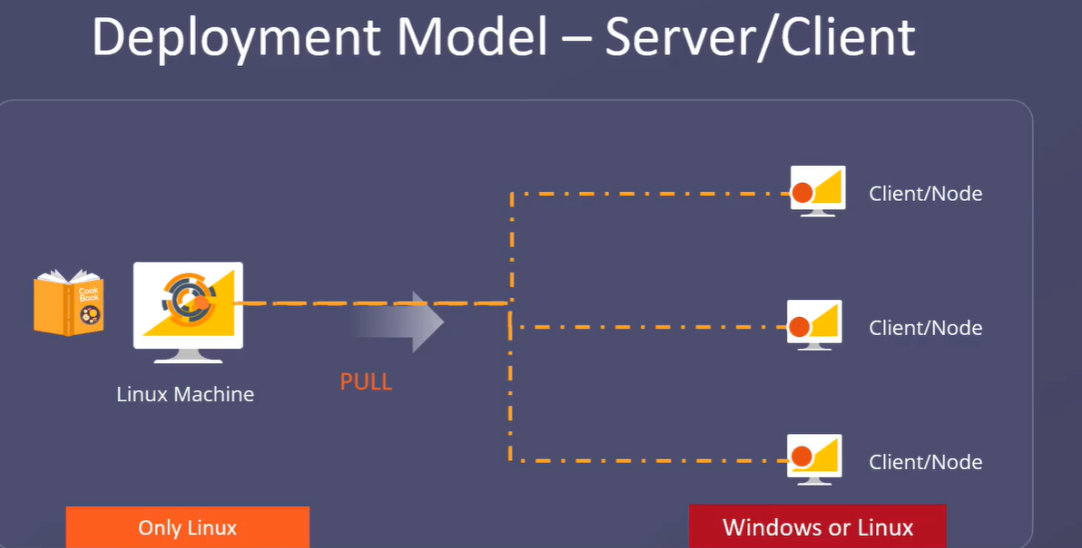
* Chef Node pulls necessary CHEF codes from CHEF Server and performs specific actions this is known as PULL based mechanism
* In CHEF ZERO both server and node will be a same server
* Chef architecture is divided into 3 parts CHEF workstation, CHEF Sever, CHEF Clients or nodes. Chef workstation is a local development center to test, apply and upload chef nodes
* CHEF workstation can be your local desktop or laptop with CHEF development kit installed on it. Chef DK consists of multiple tools like chef apply, chef client, kitchen, inspec
* Knife is used as communication tool
* Chef server is a node having chef server installed and configured
* This machine is responsible for managing chef code and acts as hub for configuring data
* Chef workstation pushes cookbook to chef server, the chef client communicates with chef server for configuration details such as chef code and other dependent files
* CHEF INSTALLATION:
* Organization is a structure that allows multiple companies or entities to exists on same chef server
* 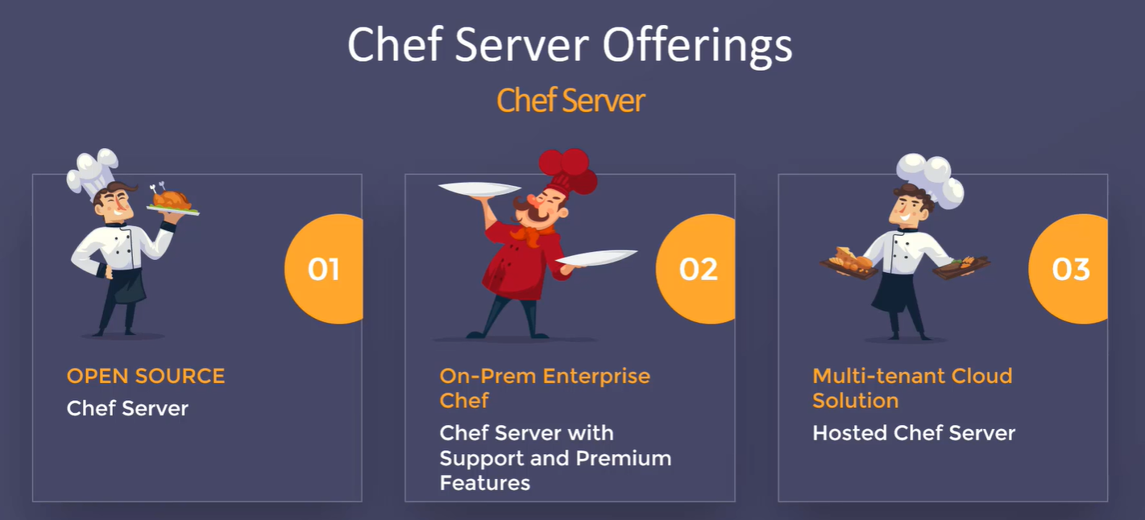
* 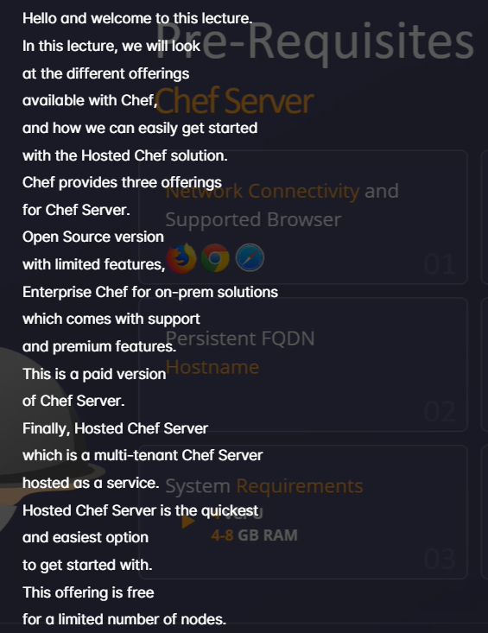
* First we need to install CHEF workstation in chef workstation
* wget <https://packages.chef.io/files/stable/chef-workstation/21.2.259/el/7/chef-workstation-21.2.259-1.el7.x86_64.rpm>
* Install CHEF:
* yum install chef-workstation-21.2.259-1.el7.x86_64.rpm
* Connecting Chef Workspace to server:
* Move Starter kit downloaded from chef.manage.io and move it to ec2 instance using WINSCP
* 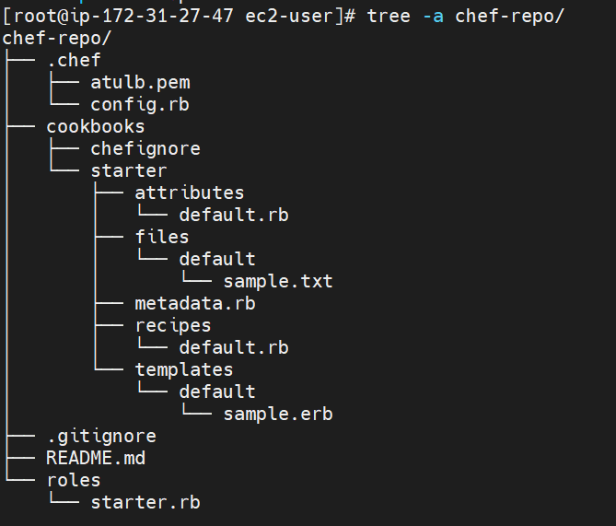
* .chef folder contains all hosted chef server info
* .config.rb contains all info about hosted client_key, cookbook path, chef_server_url
* knife ssl check -> to check workstation is able to commincate with chef server
* knife node list -> to get list of nodes attached to chef server
* knife cookbook upload <cookbook_name> to upload cookbook to chef server
* knife cookbook list to check list of uploaded cookbook
* System where we install chef client is called chef client and is managed by chef server
* we can install chef client in two ways one is using package managers like yum apt-get (yum install chef) and another method which is the suggested is using bootstrapping
* bootstrapping is process of attaching node to a chef server by install chef client package
* Knife bootstrap <private_ip_node> -U ec2-user - - sudo - - i <pem_file_node> -n <node_name>
* knife bootstrap 172.31.25.251 -U ec2-user --sudo -i ../sade.pem -N node_1
* When we run bootstrap command chef will be installed in node by default
* Knife node list will give list of node connected
* 
* 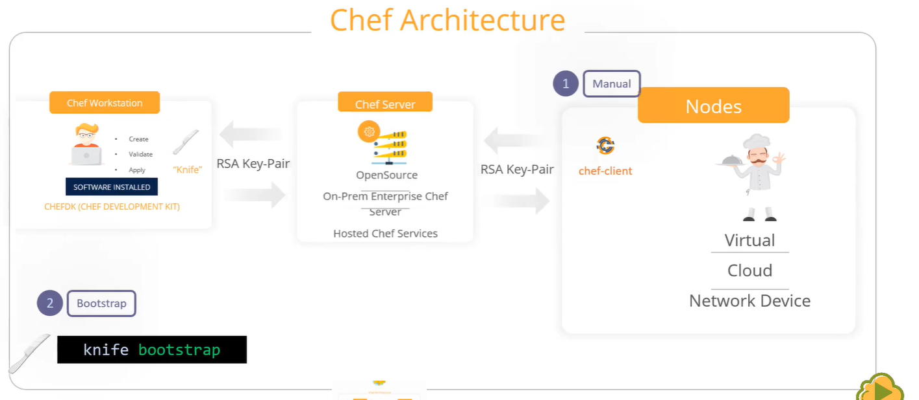
* Chef Architecture consists of Chef workstation, Chef server and Node
* Chef server stores and manages all chef code and its central repo for all configuration data such as node configuration, run list etc
* Chef workstation is a local development env for chef developer to create apply and test cookbooks
* Chef workstation can be local desktop with chef DK installed on it
* Chef WS communicates with chef server using RSA key pair
* Chef workstation uses knife to communicate with chef server
* Node is any machine, cloud or VM where chef-client is installed
* Communication b/w chef server and chef-client is established through RSA key pairs
* Everytime chef client runs it gathers info about node using OHAI and it compares node object with with the node object obtained from chef server
* 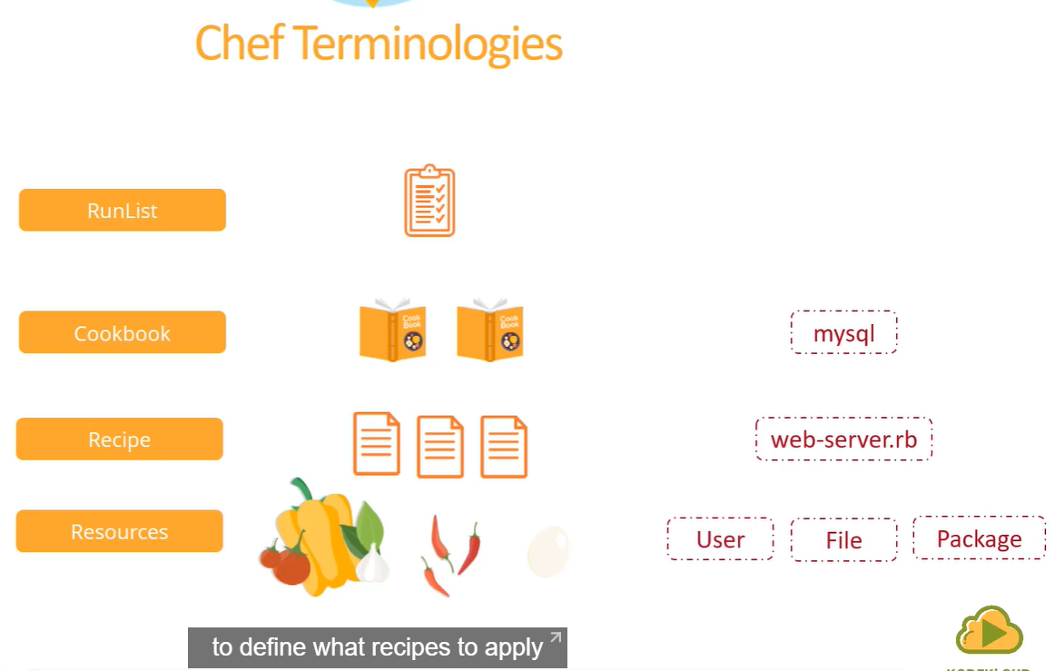
* chef resources are fundamental blocks of chef code
* resources are built in functions that gets executed at the backend to achieve a specific task
* Combinations of multiple different resources form recipe
* All recipes are written with .rb extension
* Multiple recipes form cookbook
* cookbook are collection of files and directories such as recipes, templates
* 
* 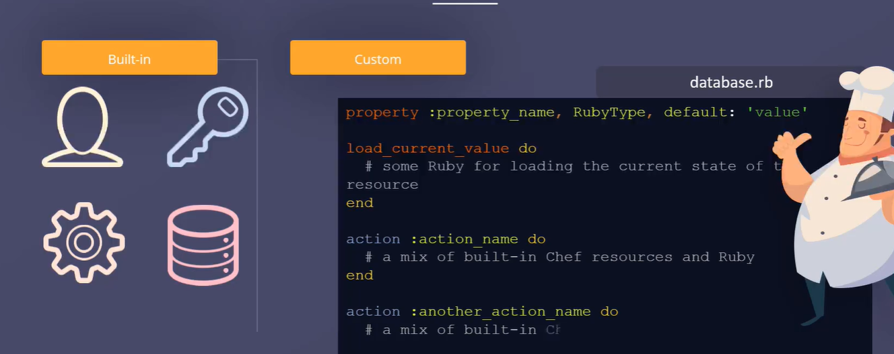
* All operations on chef client is performed using chef resources
* CHEF Domain Specific Language
* 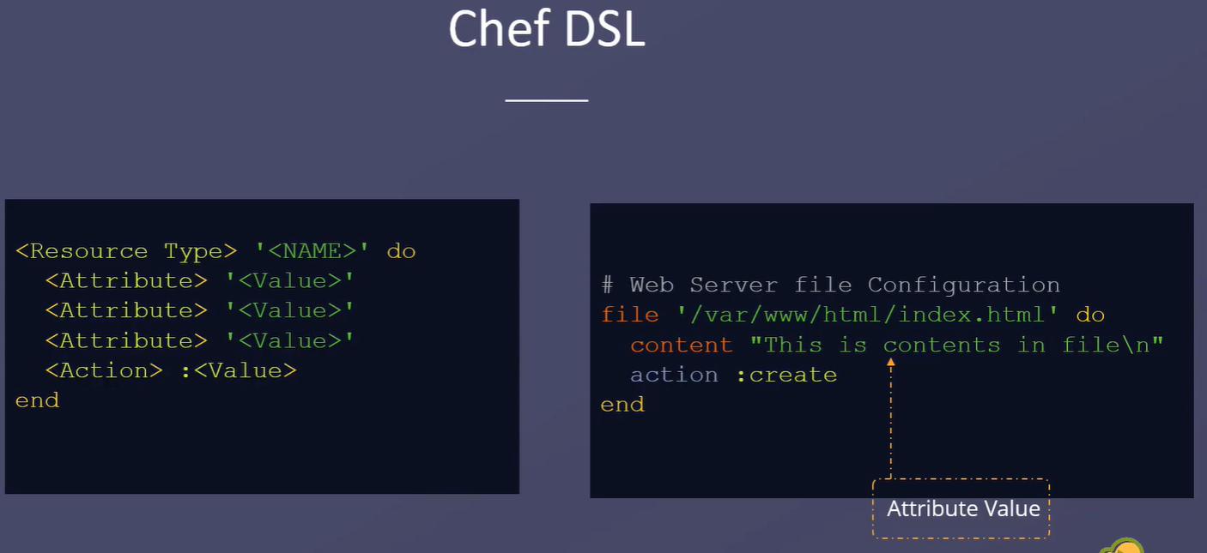
* Every resource has resource type and actions associated to it
* Every resource definition starts with chef resource type which is a keyword with no quotes
* add a space after resource type and specify name of the resource
* next is the start block which starts with “do” keyword
* next section is a key value pair each of it consists of attribute name with lower case and a space with value which are with in single quotes, double quotes or no quotes
* close the resource definition with end keyword
* 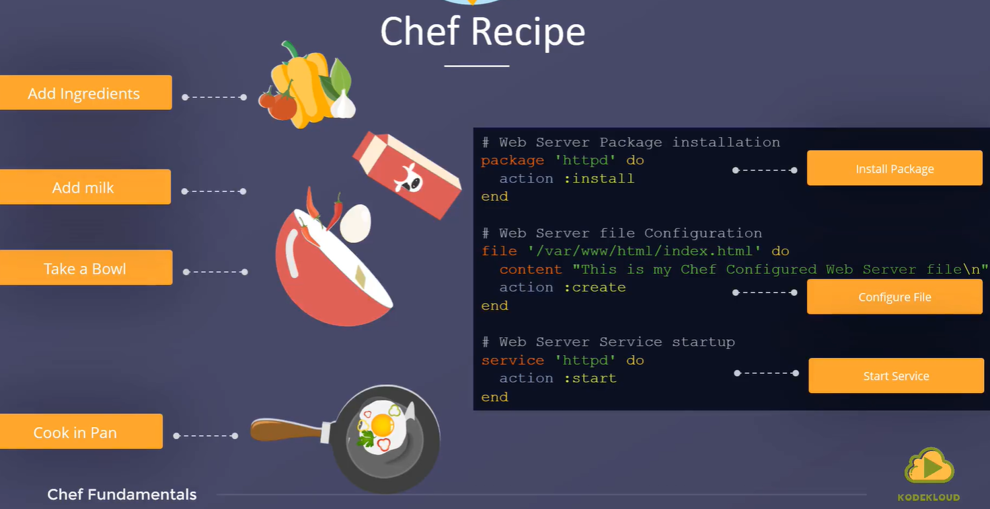
* 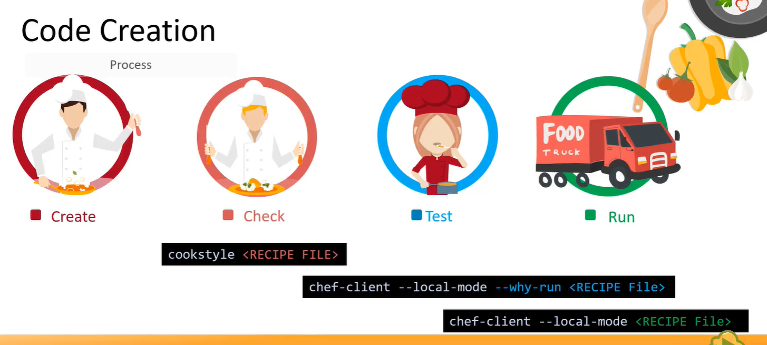
* 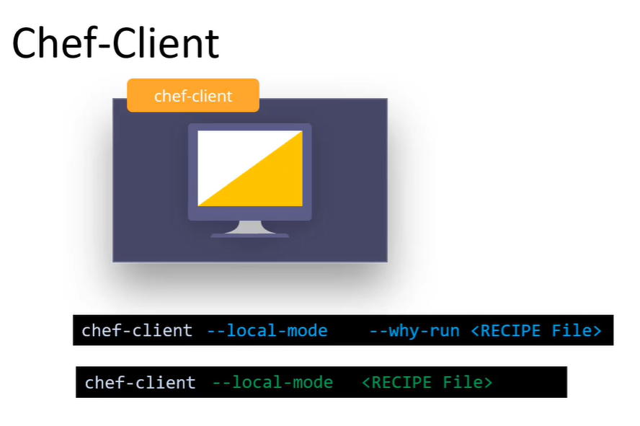
* chef resources are set of instruction/code to perform a recipe
* perform syntax check using cookstyle utility and it’s a linting tool
* next peform a smoke test to check recipe is working as expected by using –why-run option
* chef generate cookbook <cookbook_name>
* 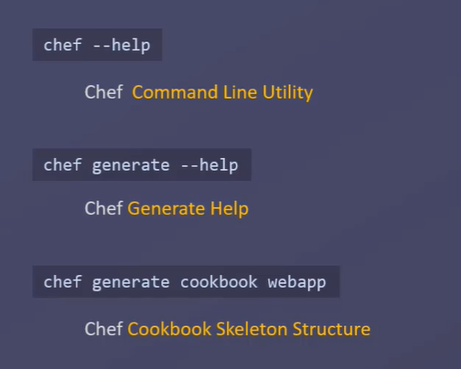
* 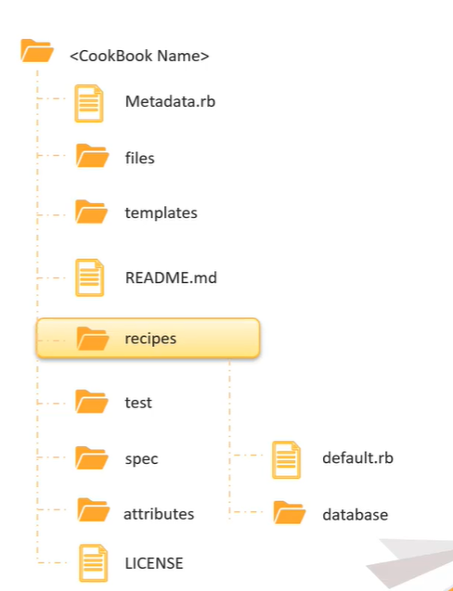
* 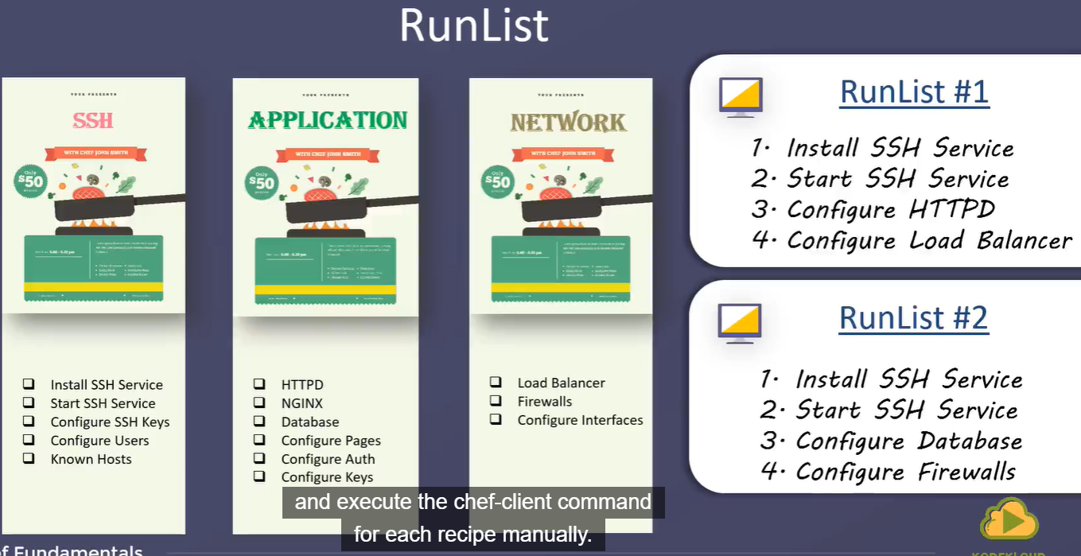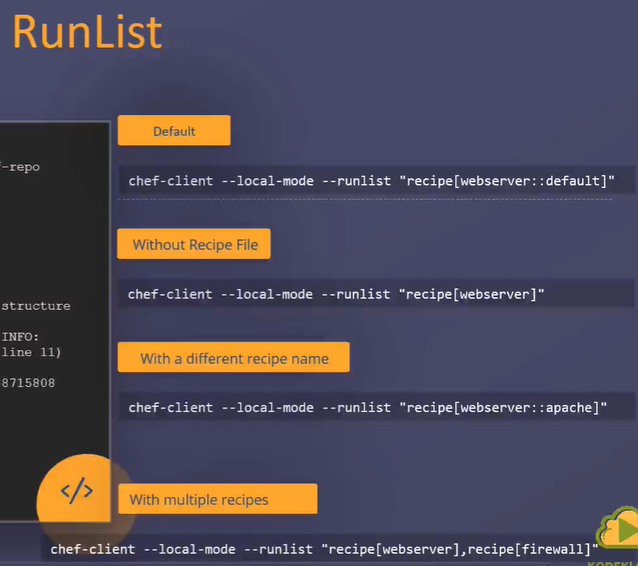
* we have multiple recipes across multiple cookbook, a customer may choose to order any recipe based on his needs and also order of delivery is very important
* runlist in chef are like orders, it defines what recipes needs to be run and in which order
* 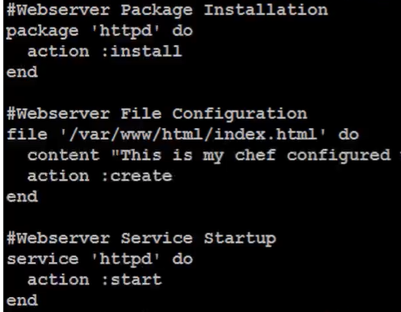
* Include Recipe: 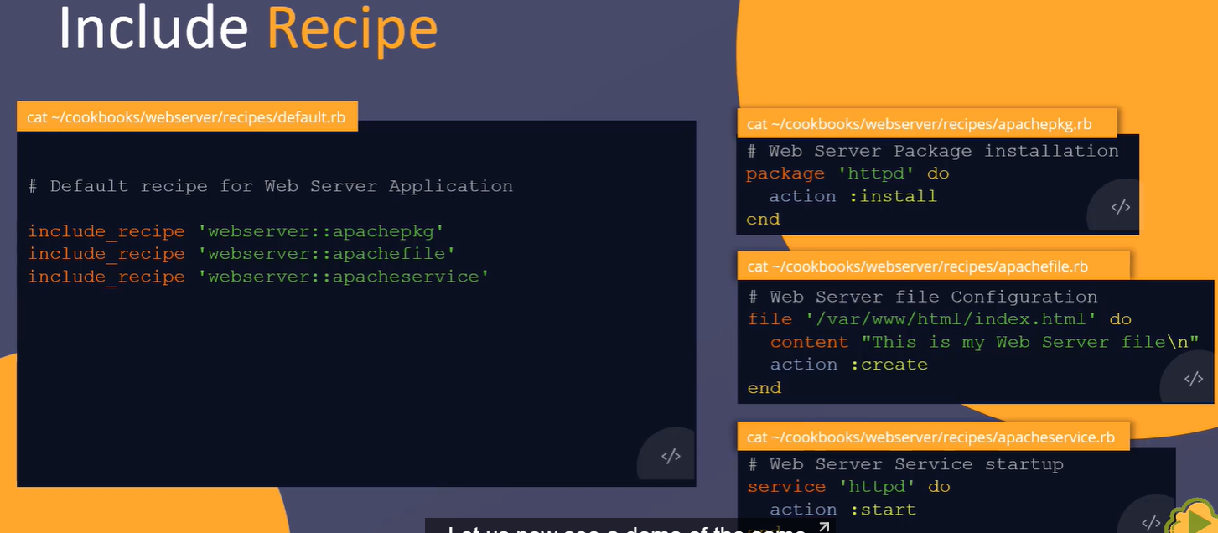
* If the number of recipes increases it become complex to add all recipes as part of runlist instead we can use include_recipe and add all recipes over there
* Cookbook Dependencies
* 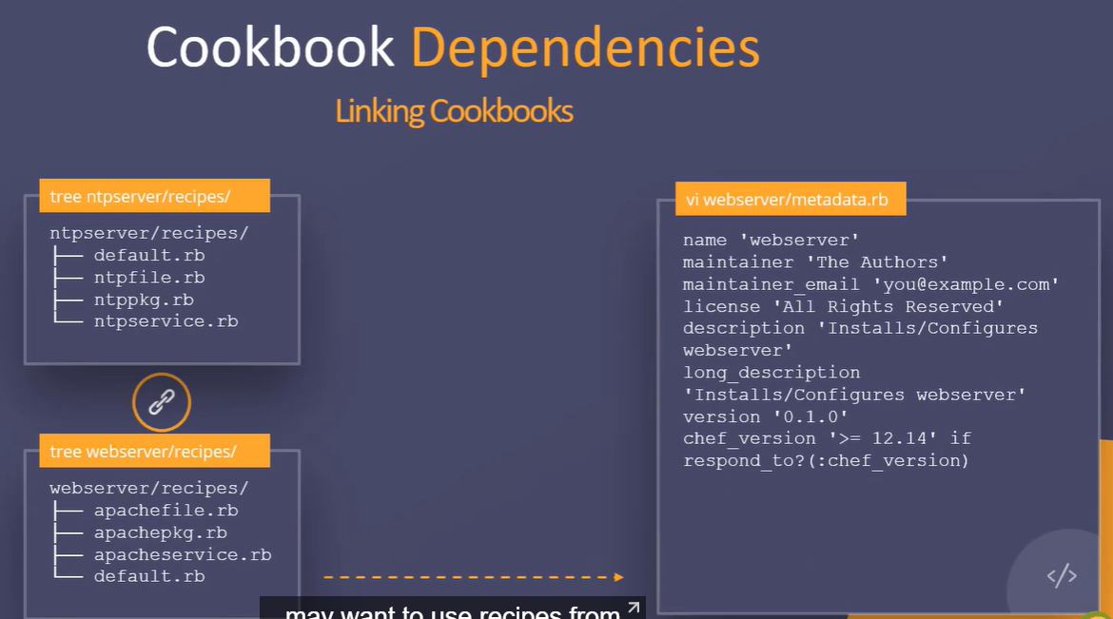
* At times we may have to use recipes from another cookbook, for that we need to create dependcies between two cookbooks
* 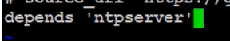
* 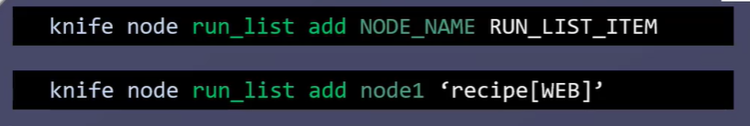
* 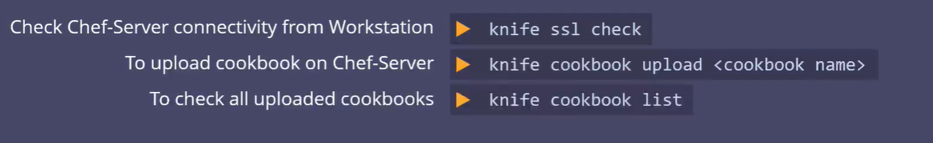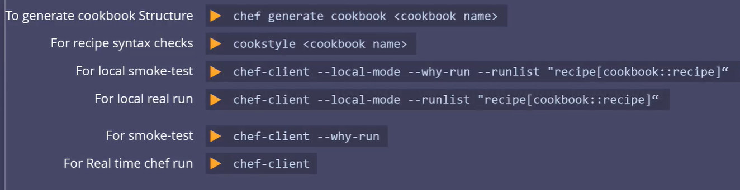
* Ohai is a tool which is used to collect system configuration data
* Ohai is run by chef client to determine current system state
* 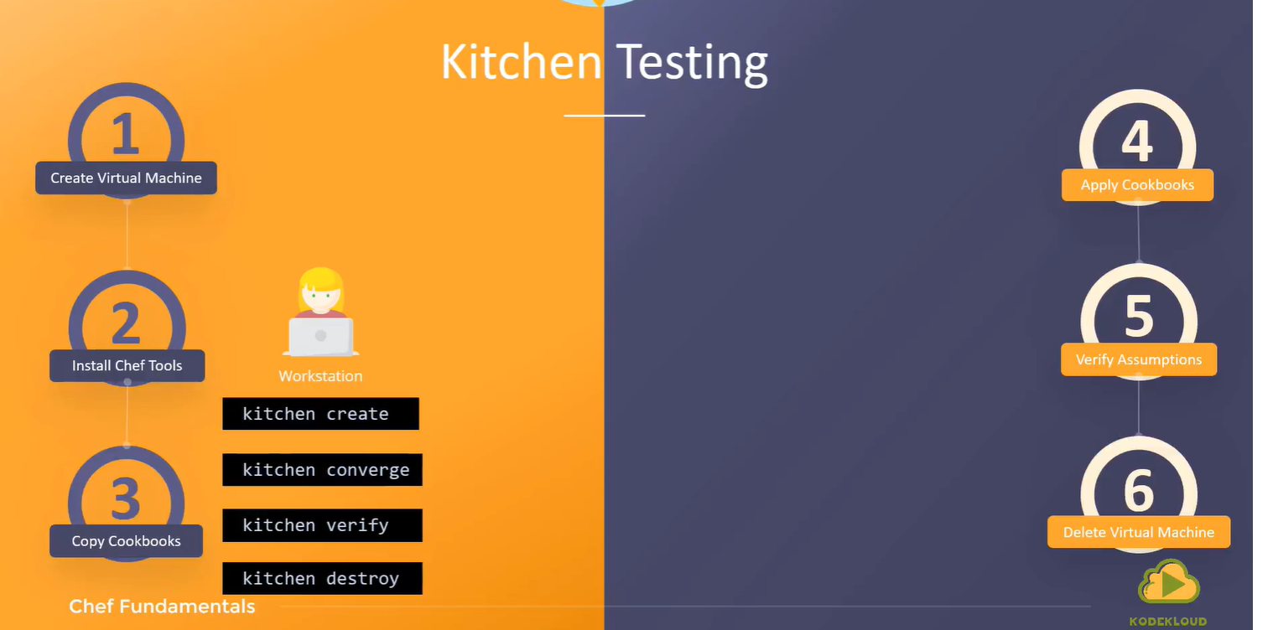
* 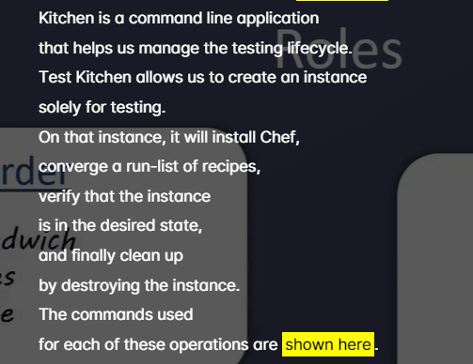
* ROLES:
* 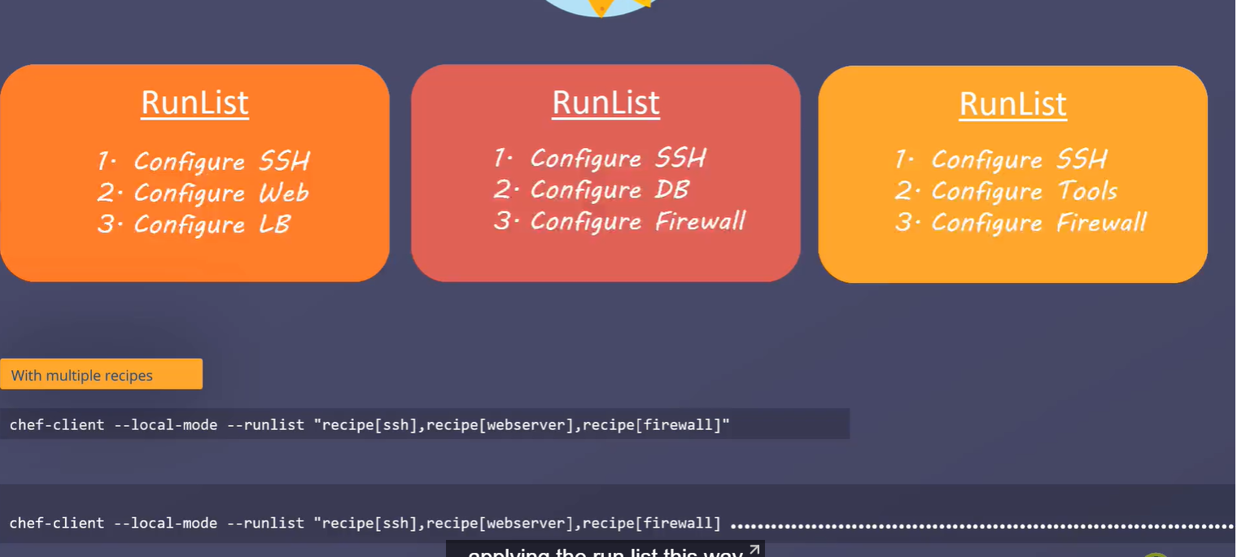
* 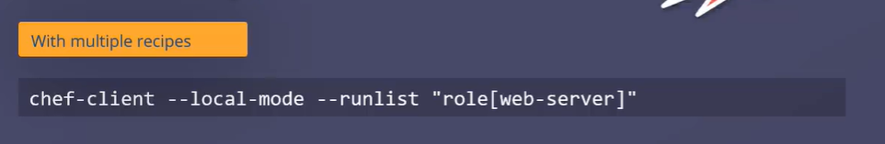
* When the nu,ber of recipies in the runlist increases applying runlist in this way gets complicated
* Its better to have these recipies as combo
* we now configure run list into a role such as webbrowser or db and we can easily apply those roles into the nodes
* 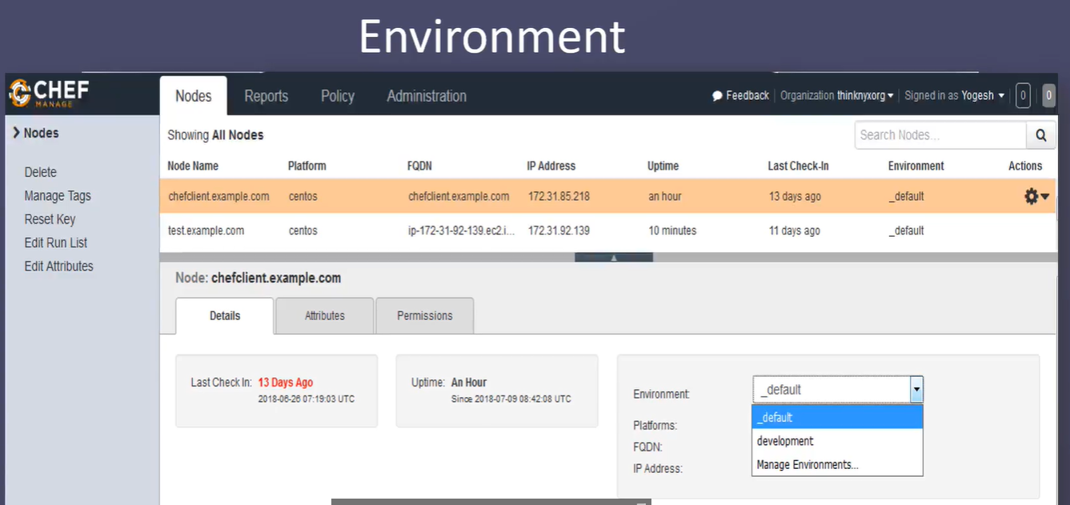
* Environments helps us to group nodes based on the stage
* Once we install chef we automatically get two softwares:
* Ohai
* Chef CLient
* chef generate cookbook test-cookbook
* To generate recipe we need to be inside cookbook not under recipe
* chef generate recipe test-recipe
* Only to create recipe we need to be inside cookbook, for all other operations we need to be outside cookbook
* chef-client -zr "recipe[apache-cookbook::apache-recipe]"
* -z to run in local
* -r for run list
* Convergence means calling chef client to apply recipe to bring node to desired state, this entire process is called convergence
* We can run multiple recipe but only one recipe can be considered from each cookbook
* 
* Using include recipe we can call multiple recipe from same cookbook but we can’t call from multiple cookbooks, we can do this by calling recipe inside default recipe
* By Combining include_recipe and run_list we can call any number of recipe from any cookbooks
* **run knife ssl check** to check connection is established
* Bootstrap node to server
* Knife bootstrap <private_ip_node> -U ec2-user –sudo – I <pem_file_node> -n <node_name>
* knife bootstrap 172.31.25.251 -U ec2-user --sudo -i ../sade.pem -N node_1
* When we run bootstrap command chef will be installed in node by default
* Knife node list will give list of node connected
* Knife cookbook upload <cook_book_name>
* To check cookbook is uploaded or not
* To check uploaded cook-bbok
* Knife cookbook list
* Now we need to link recipe to node, for that go to workspace
* 
* knife node run_list set Node1 "recipe[apache-cookbook::apache-recipe]"
* 
* To delete a node
* knife node delete <node_name> -y
* knife cookbook delete <cook_book_name> -y
* Whenever we bootstart a client will be created same name as node_name, by using client node will be connected to server
* To delete client
* Knife client delete <node_name> -y
* We will create a file under roles and paste below content
* we need to attach node to the roles for that command is
* knife node run_list set NodeA "role[web]"
* knife node run_list set NodeB "role[web]"
* knife node show NodeA
* Instead of attaching node to recipe we are attaching node to role
* 
* To run all recipe of all cookbook
* Assume I have 3000 nodes connected
* If we need to attach a recipe to all 3000 nodes that is a huge task and we need to automate that, so we use roles
* name "web"
* description "web server role"
* run_list "recipe[apache-cookbook::apache-recipe]"
* and name it web.rb
* To upload the role:
* Knife role from file roles/web.rb
* name "web"
* description "web server role"
* run_list "recipe[apache-cookbook::apache-recipe]"
* we need to attach node to the roles for that command is
* knife node run_list set NodeA "role[web]"
* knife node run_list set NodeB "role[web]"
* knife node show NodeA